**Project: Auto-Scaling Web Application for Seasonal Traffic.**

In this project, we will guide you through the process of creating EC2 instances and hosting a free CSS website after that creating a using powerful tools – AWS EC2 Autocaling, AWS SNS Alert, Load Balancer, Target Group to Improving Availability & Reliability of application.

This project name reflects the use of Amazon EC2 Auto Scaling for managing the compute capacity, a Load Balancer for distributing traffic, a Target Group for routing requests, and SNS (Simple Notification Service) for sending alerts.

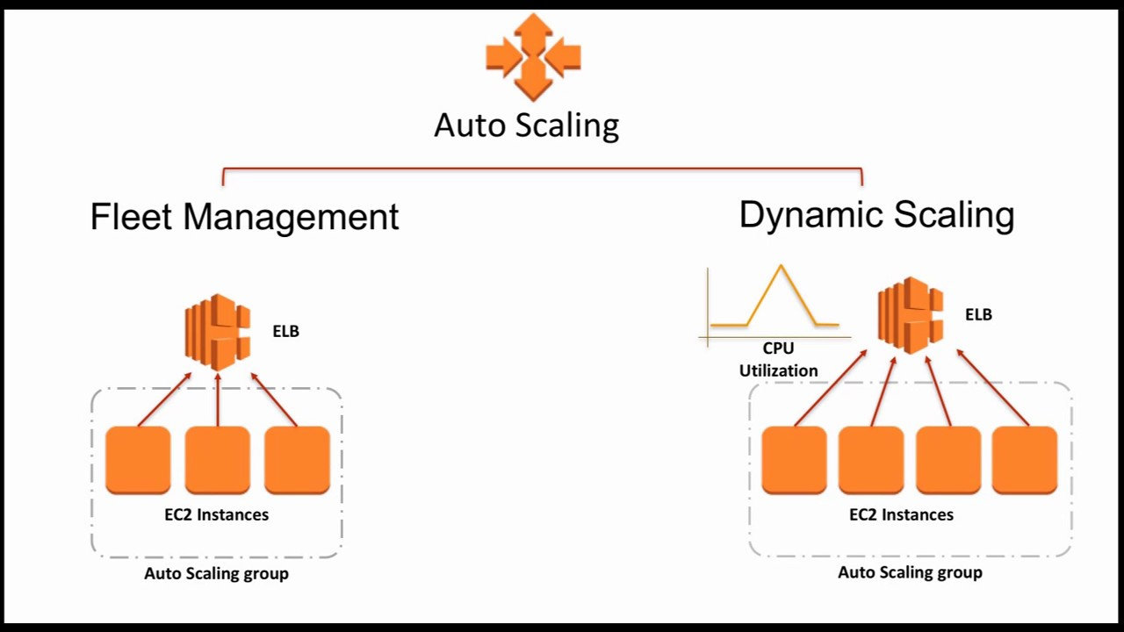

**#Step 1: Launch an instance & create an AMI of EC2 Instance.**

# First, launch an Amazon EC2 instance with default configuration.

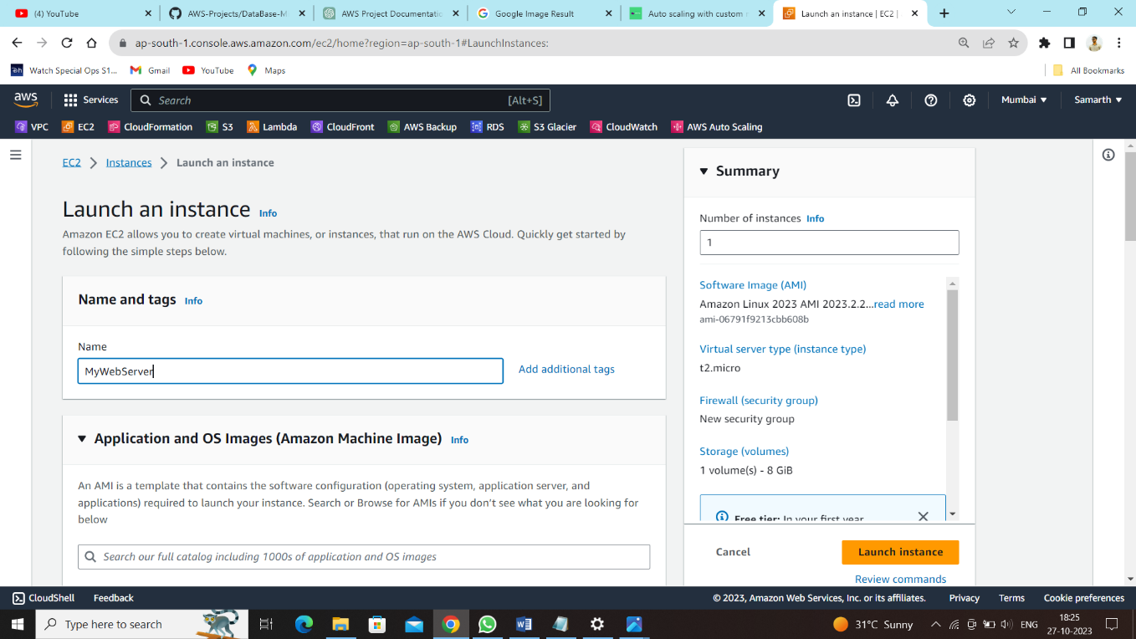

Connect to the EC2 instance with Linux OS

Commands Used:

sudo su

yum install httpd –y

systemctl start httpd

systemctl enable httpd

wget <https://www.free-css.com/assets/files/free-css-templates/download/page285/a-world.zip>

unzip a-world.zip

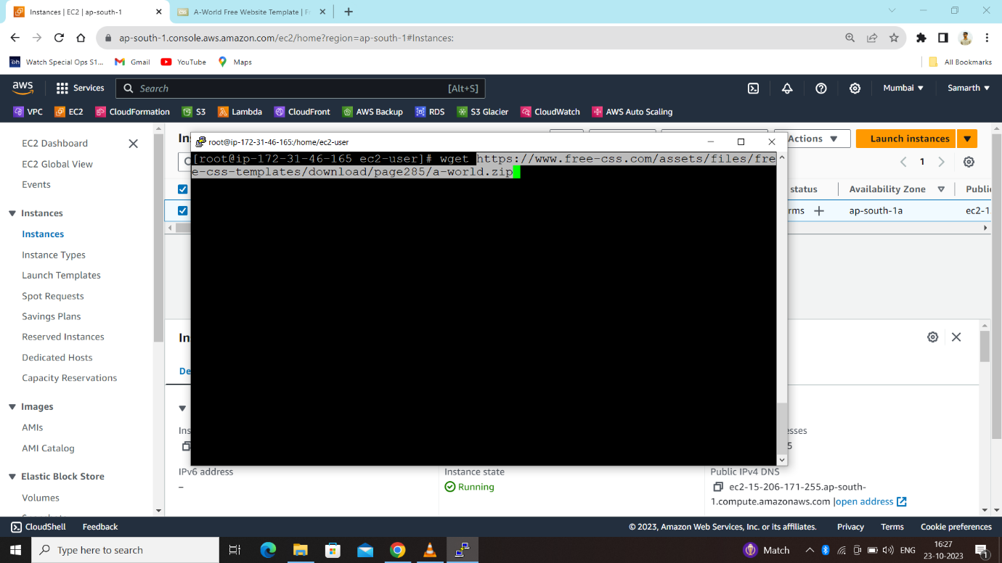

After Unzip file then (vim index.html) edit the title name & banner name for our understanding.

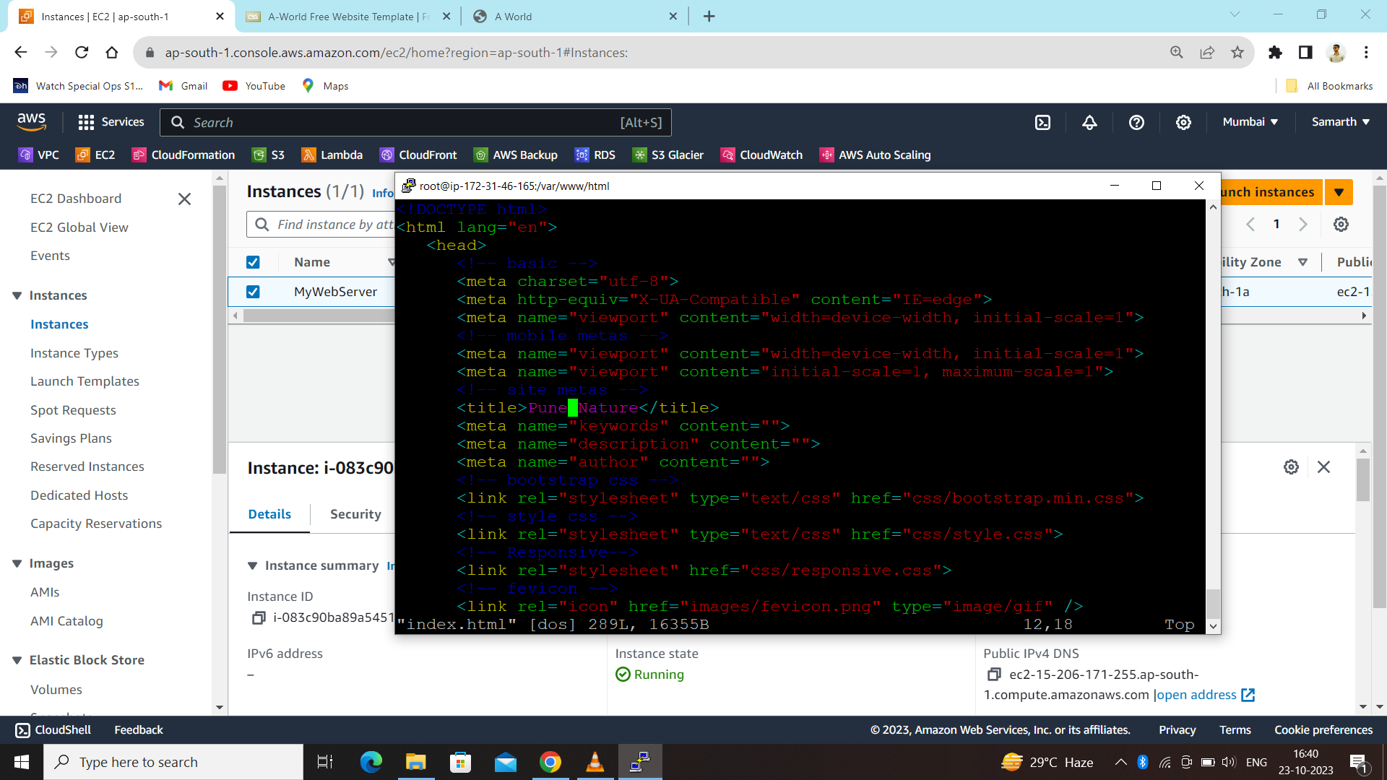

After Hosting Website Create a AMI image of that EC2 Instance as a backup for further usage. During AMI creation time, a snapshot of the volume will be taken. There is provision to tag the image and snapshot together or separately.

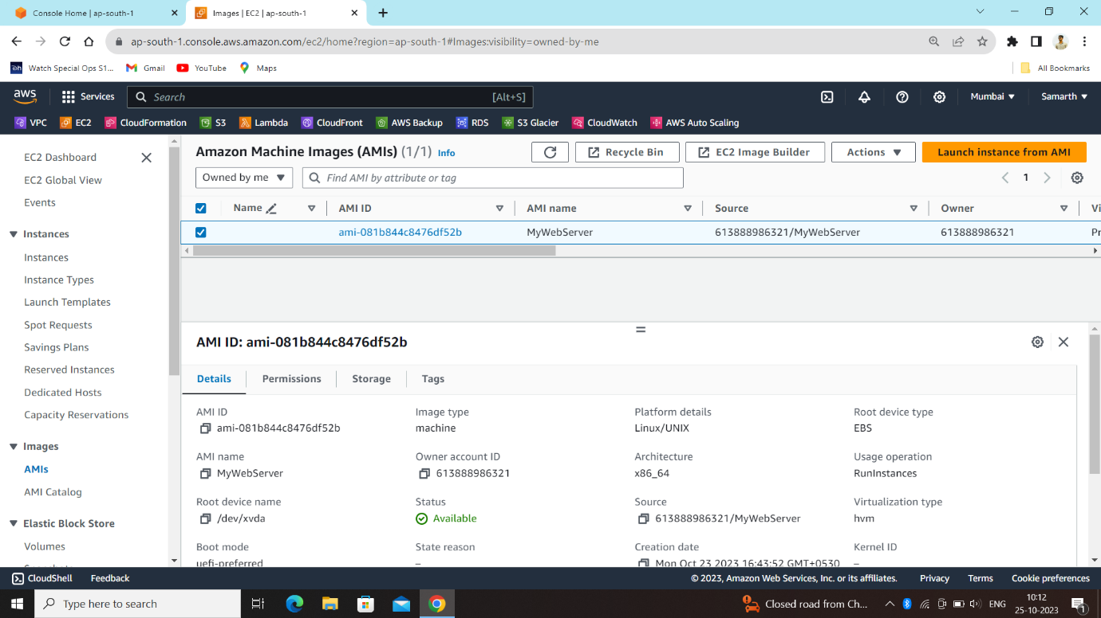

**#Step 2: Create an Auto Scaling Group:**

Create an auto scaling group with the Launch Configuration in it to create template then select our created template.

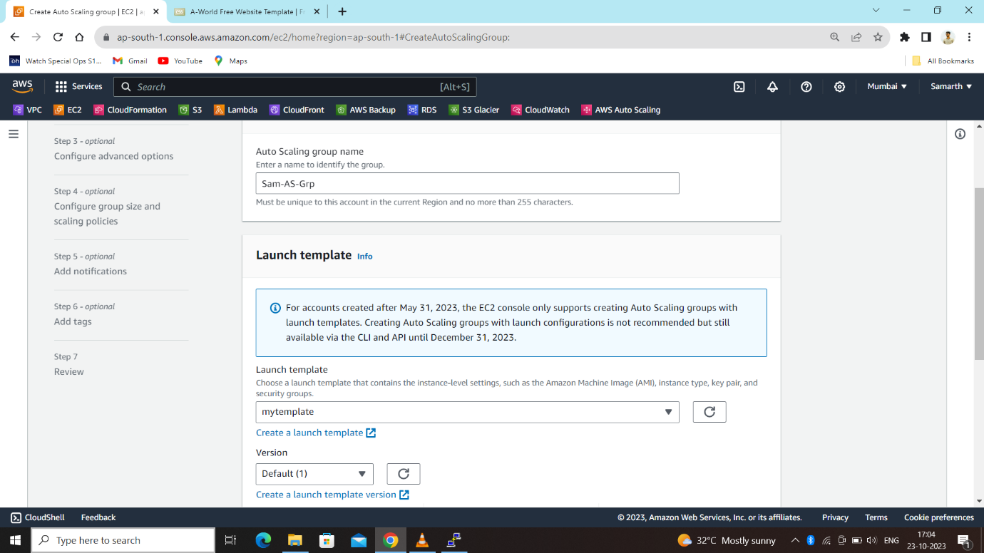

**Configure group size and scaling policies:**

**Create a Target Group-**

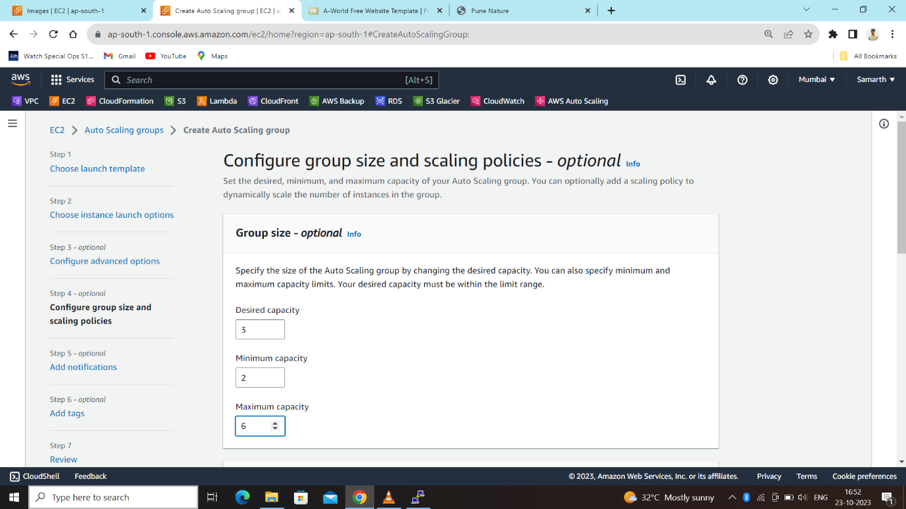

Choose the desired / minimum and maximum capacity needed.

**Desired capacity**: Represents the initial capacity of the Auto Scaling group at the time of creation. An Auto Scaling group attempts to maintain the desired capacity.

**Minimum capacity**: Represents the minimum group size. An Auto Scaling group cannot decrease its desired capacity lower than the minimum size limit.

**Maximum capacity**: Represents the maximum group size. An Auto Scaling group cannot increase its desired capacity more than the maximum size limit.

After that Set the Target tracking scaling policies and CPU Utilization About 60%.

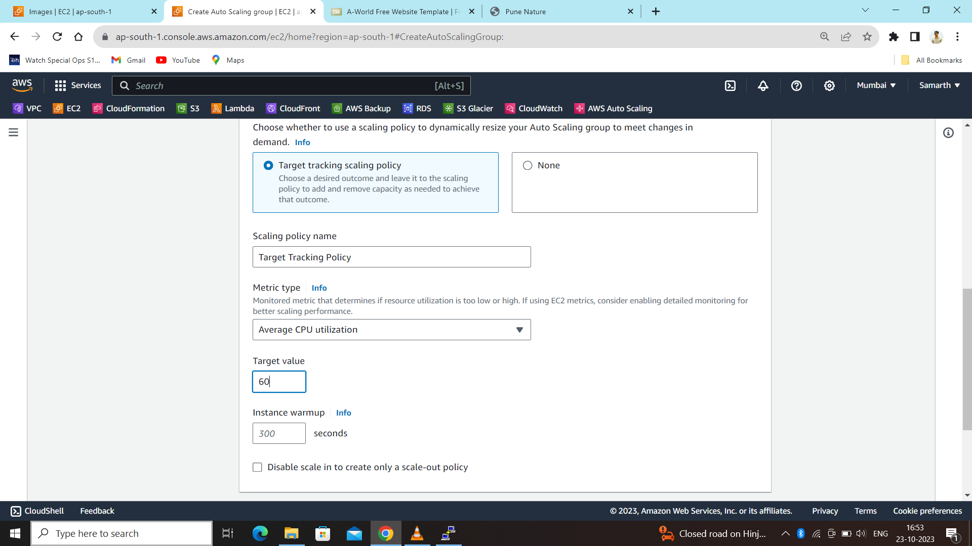

**Create a Load Balancer –**

While creating load balancer select Attach to a new load balancer then select type Application Load balancer with internet-facing scheme. After that keep the VPC setting as default and choose the subnets (1a, 1b) where these instance need to be launched. We are opting Attach new load balancer option with health checks on EC2 at instance warm-up period of 300 s.

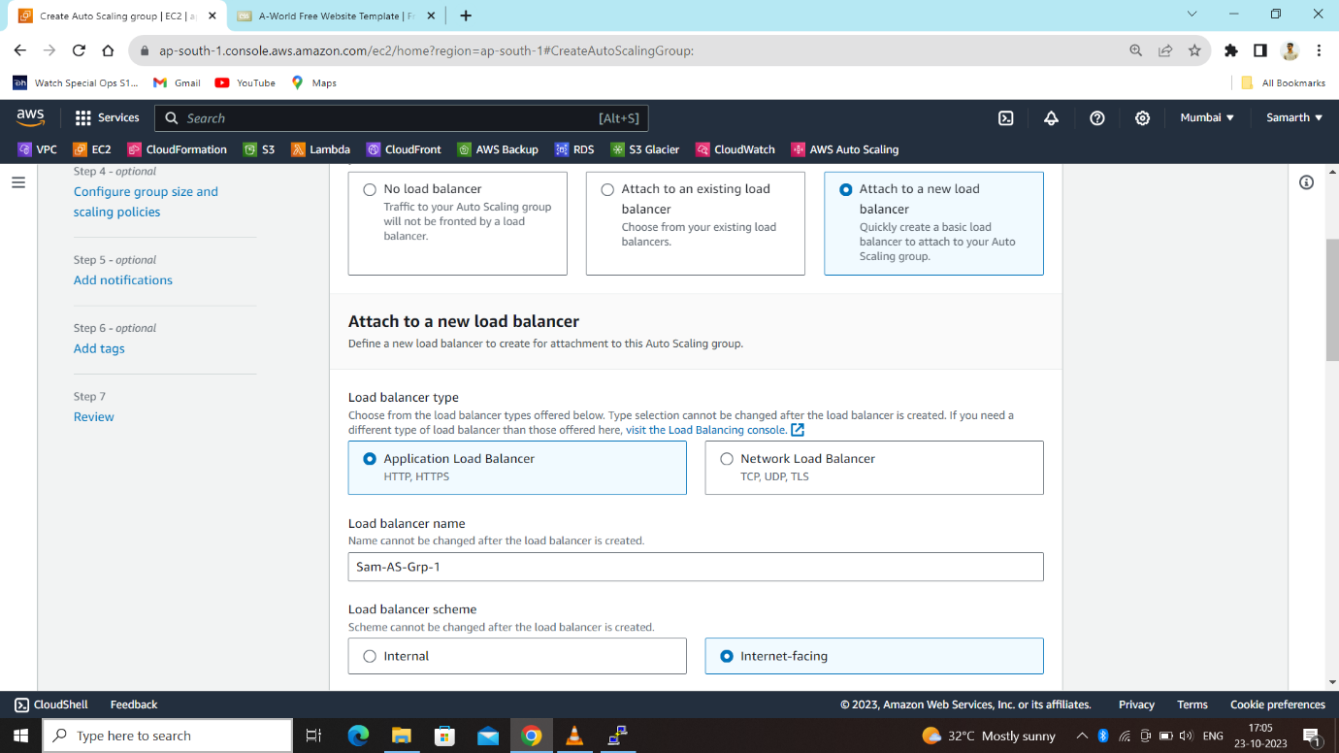

**Step 3: Create an Alarm (**Add Notification) **-**

Create an alarm based on the memory used percent custom metric. For Notifications, choose the default SNS topic for Cloud Watch Alarms and enter your email id to get the notification in case of new instance launch or instance terminated.

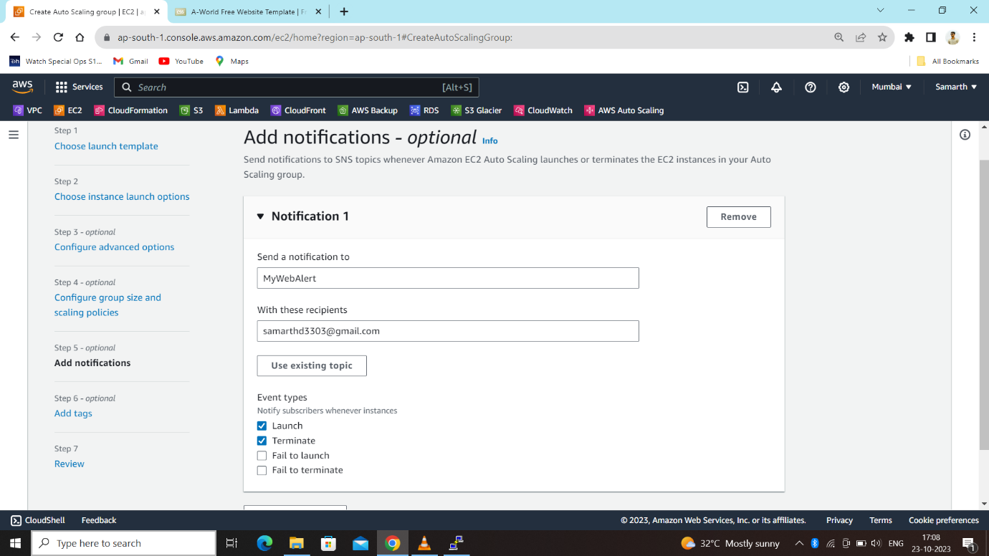

After all the configuration set create autoscaling group, we can see new 3 instances are launched as per our seted desired capacity.

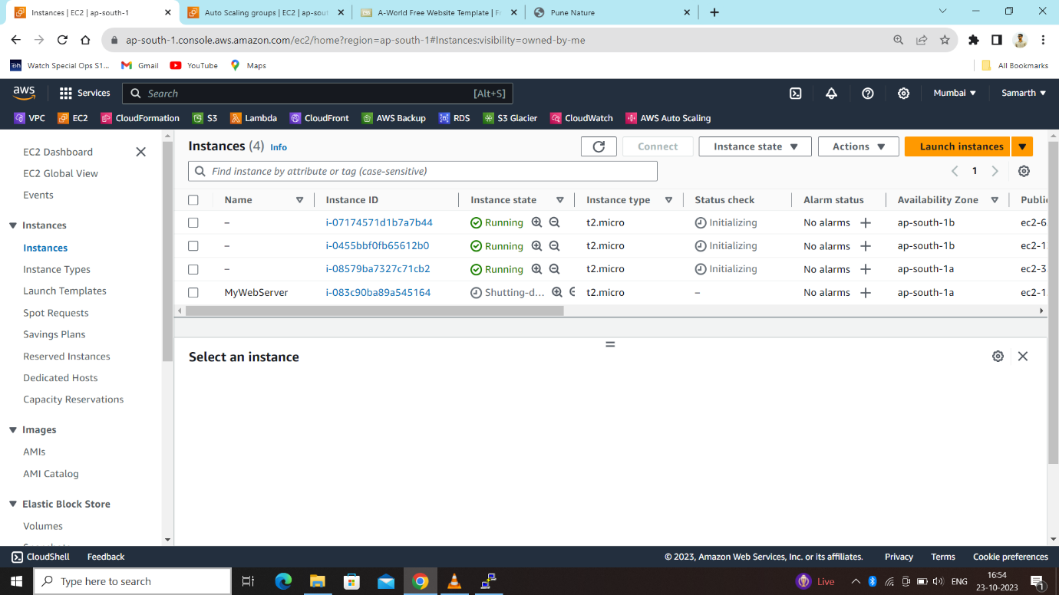

Now, In EC2 instances Select load balancer then copy the arn of the load balancer we created (sam-as-grp-1-1935932416.ap-south-1 elb.amazonaws.com) paste it on any browser to check our website working fine & also to increase the load on it.



Now out of 3 delete 2 instances for launch a new instance as we know we seted at least 2 instances are working fine.

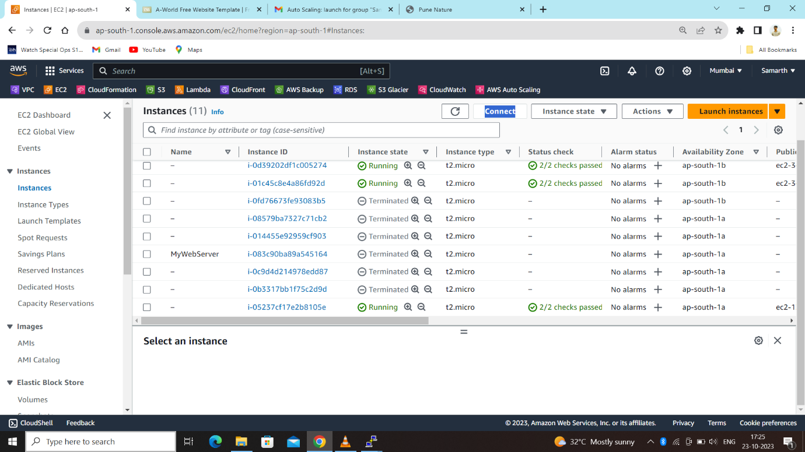

Here we get a notification of termination of instance from SNS:

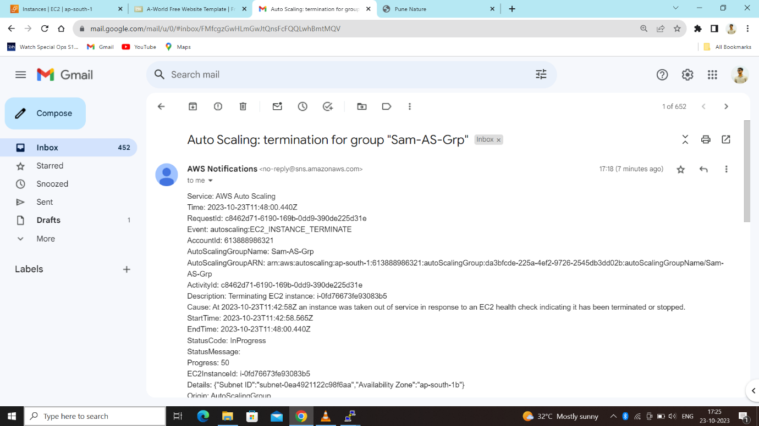

Here we can see our instances automatically launching after deletion of 2 instances.

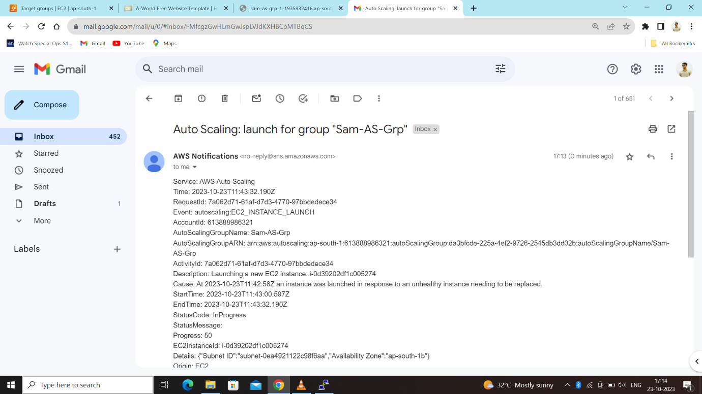

Now to increase number of instance we have to increase traffic on our website with the help of this command **(yes > /dev/null &)**.

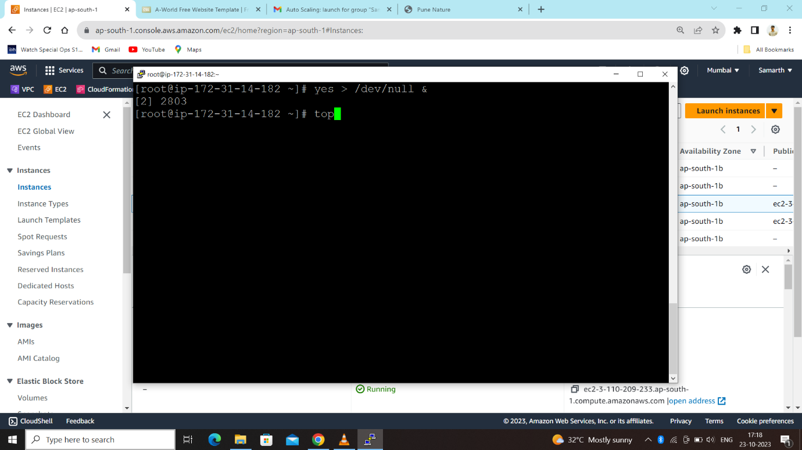

Suddenly our CPU Utilization goes above 90% so it can launch more instances to handle load on website and also ensuring customers that our site work on high availability & reliability.

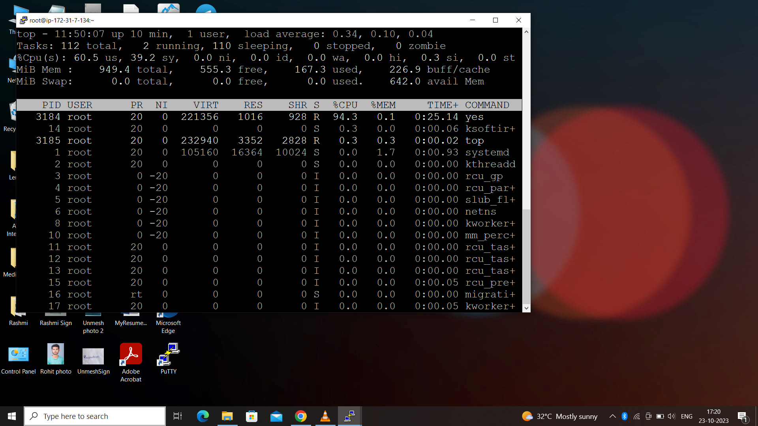

Now increasing load on all 3 running instances ;

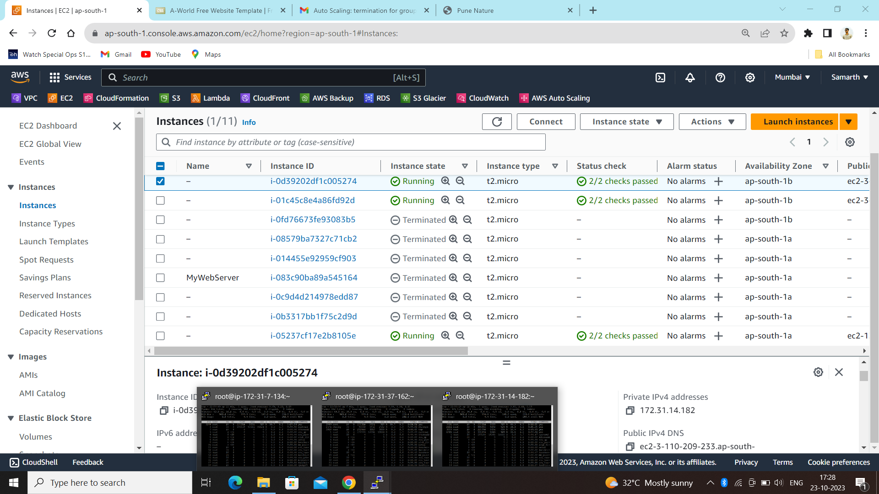

After increasing load on all 3 instances here we can see all the 6 instances were launched with its maximun capacity seted.

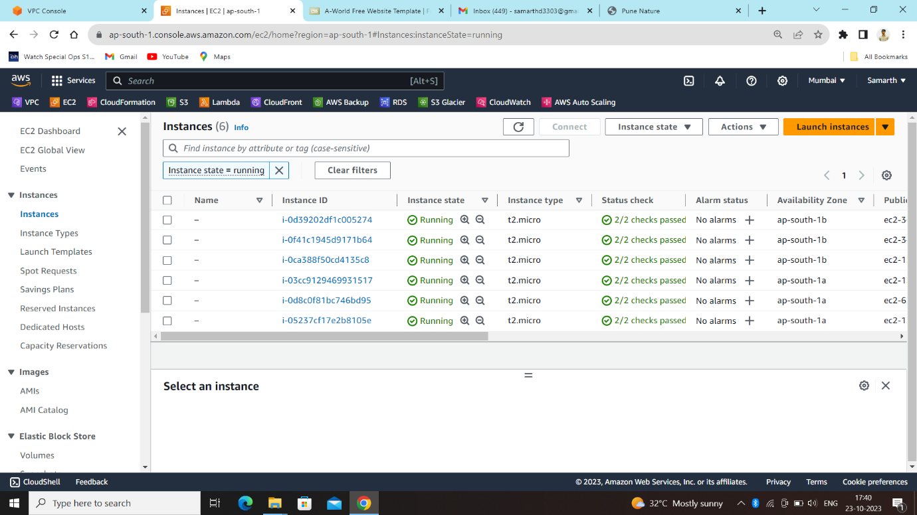

Now to clean up, if you stop the instances manually, ASG will again spin up new instances as per the desired capacity. Instead set the minimum and desired capacity in ASG as zero.

That’s it. We have successfully completed EC2 Auto scaling with SNS Alerts.